Nepal College of Information Technology
Assessment
Spring 2012
Program : ELX Time : 3 hrs
Semester : (VI) FM : 100
Subject : Filter Design PM : 50

- Candidates are requested to give their answer as far as practicable in their own words.
- The figure in the margin indicates the full marks
- Attempt ALL question
- Assume suitable data if necessary
1. a) Define scaling and derive the expression to determine the new value of circuit elements in frequency, magnitude and both frequency and magnitude scaling. [2+6]
b) What is the importance of frequency transformation in filter design? Find the band pass filter network, assuming suitable low-pass prototype network by using frequency transformation. [2+5]
2. a) Explain the Inverse Chebyshev approximation for low pass filter and derive an expression for the order (n) of the filter. [4+3]
b) Consider a filter with Butterworth response with the following specifications:
Passband attenuation: 0.5 dB
Stopband attenuation: 20 dB
Passband edge frequency: 1000 rad/sec
Stopband edge frequency: 2000 rad/sec
Determine the order of the filter, half-power frequency and network function. [3+2+3]
3. a) Realize the third order Butterworth lowpass filter for the singly terminated arrangement as shown below: [8]
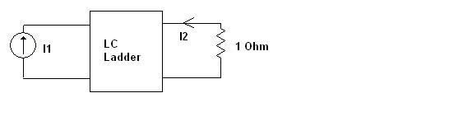
b) Design a circuit to realize the bilinear transfer function with a zero at f_{Z} = 830 Hz, a pole at f_{P} = 13 KHz, a high frequency gain of 23 dB using inverting configuration. [7]
4. a) How Tow Thomas Biquad is used to determine the transfer function for the Bandpass filter? Design a bandpass filter with centre frequency of w_{o} = 1000 rad/s (f_{o} =159 Hz) and a bandwidth of 200 rad/s. The midband gain must be H = 1. [5+5]
b) Perform sensitivity analysis for Tow- Thomas Biquad. [5]
5. a) Design a switched capacitor filter to realize the transfer function. [8]
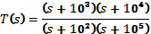
b) Design a lowpass MFB for G=5, b₁=1.2, b₀=1. Scale to obtain the element in practical element values. [7]
6. a) Consider below the designing of a fourth order Butterworth filter with half-power frequency of f₀= 10³ Hz. Source and load impedances are R= 3 KΩ. The design should make use of FDNRs. [7]
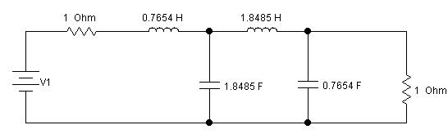
b) Design a fourth-order Butterworth lowpass filter using the cascade of two Sallen-Key biquads using Design 1 and 2 respectively. Let w₀= 2π × 1000 rad/s and use 0.1 µF capacitor. [8]
7. Write short notes on: ( Any Two) [2*5]
a) Insertion gain and Insertion loss
b) Transmission and Reflection Coefficient
c) RC-CR Transformation in Filter Design
d) Generalized Impedance Converter ( GIC)

